**Cloud Computing – Lab 4**

**Anudit Nagar – E18CSE024**

**Scenario 1**

Create a Custom VPC in an Availability Zone at one region and Create all its necessary components such as Subnet, IGW and Route Table.

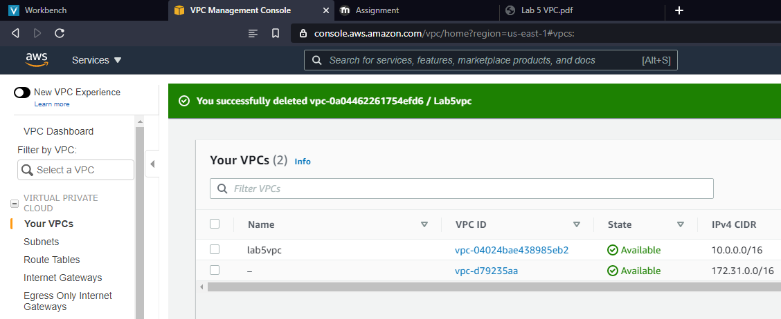

Launch a linux server free tier t2.micro in the public subnet only and allow all traffic.

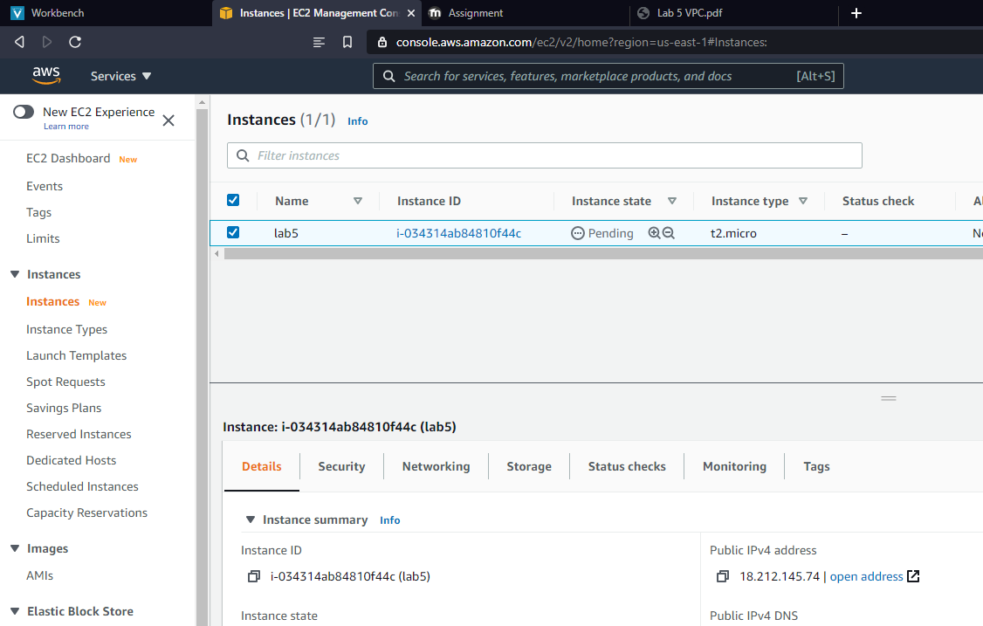

Create a custom Network ACL and attach the subnet of default NACL

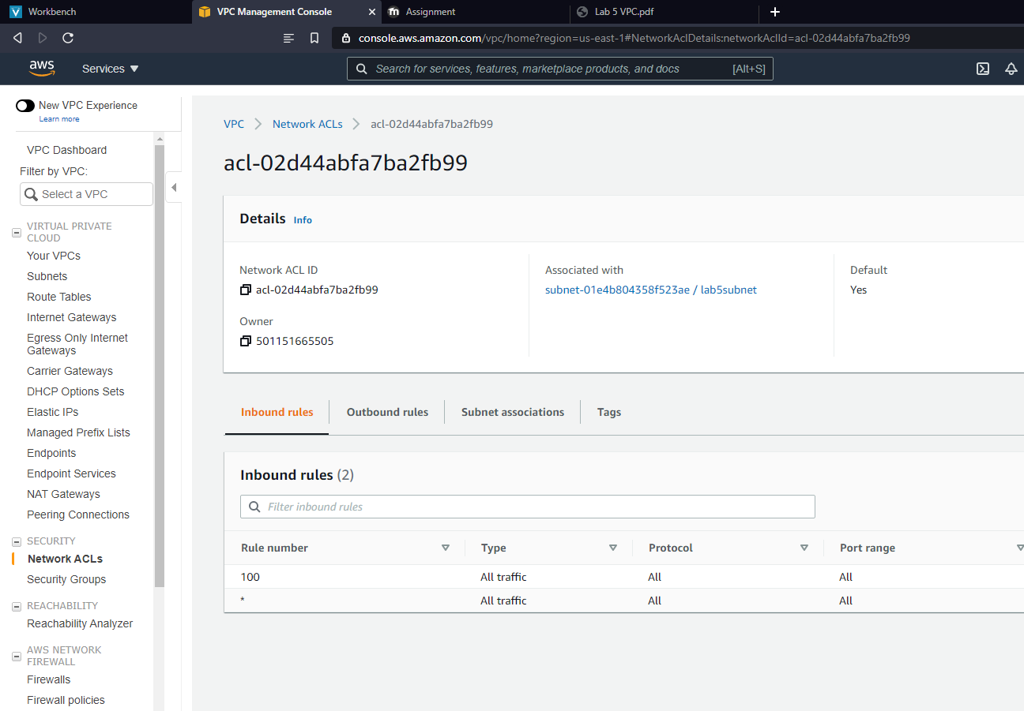

Check the internet connectivity using CMD or Browser.

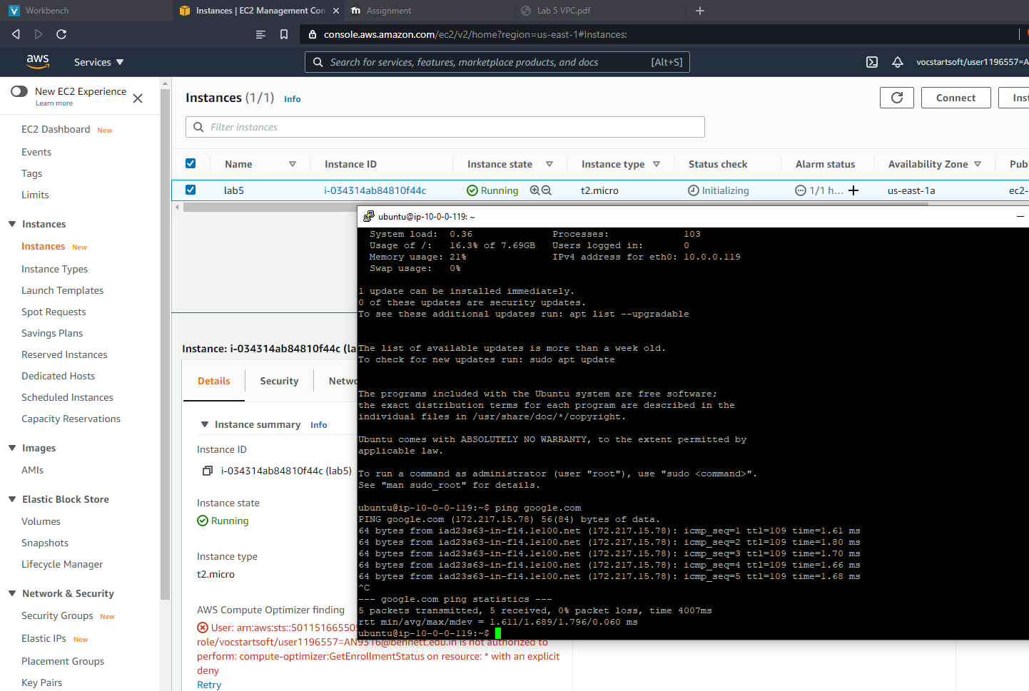

**Scenario 2**

Create VPC by creating 2 subnets in it (one private and one public). (Other components IGW, Route Tables will also be there)

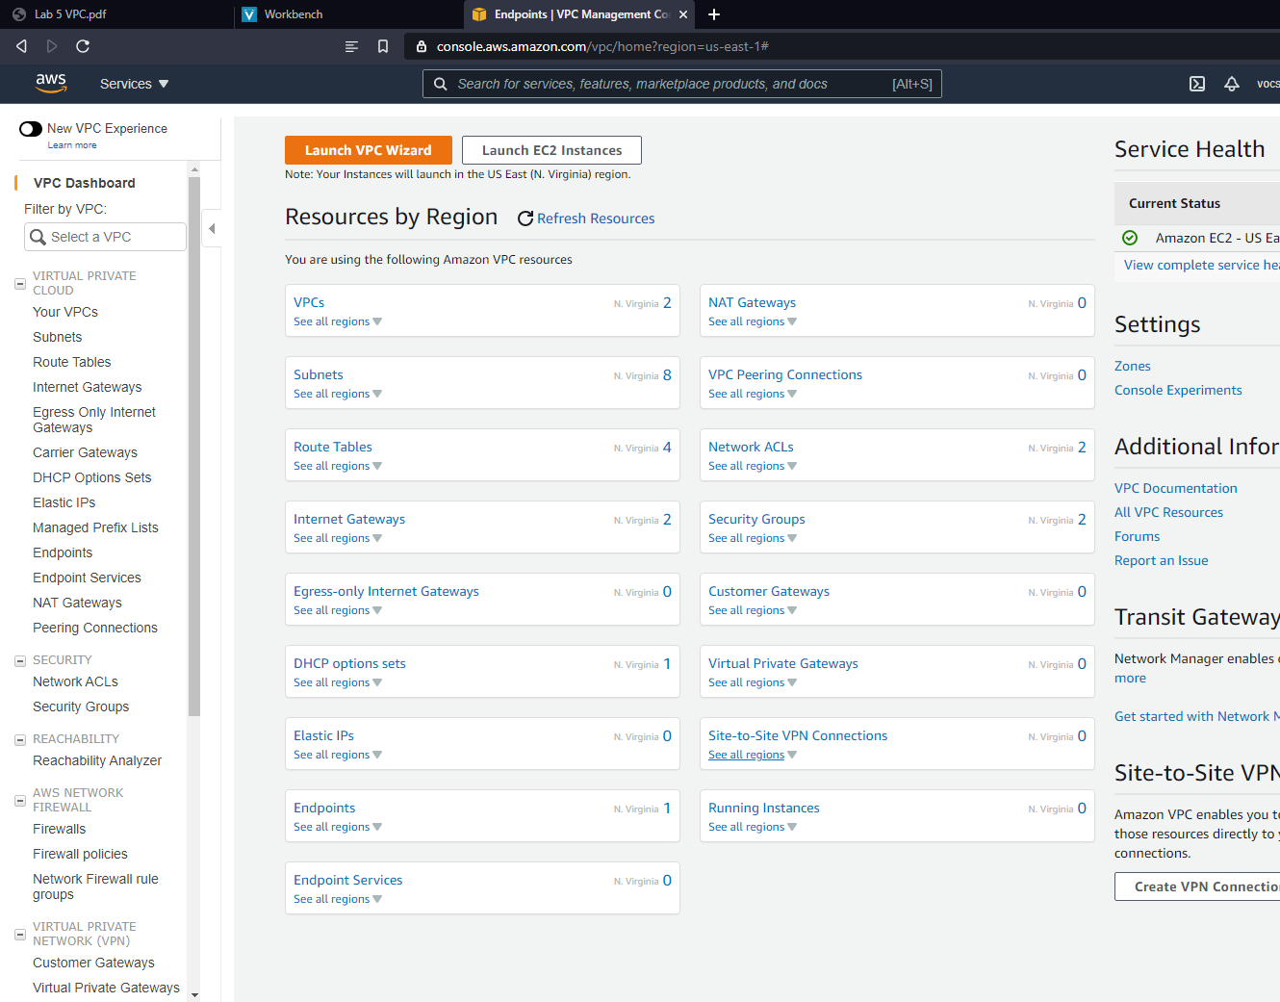

Launch two EC2 Linux server in the subnet one for one and Create a VPC Endpoint and associate it in private subnet.

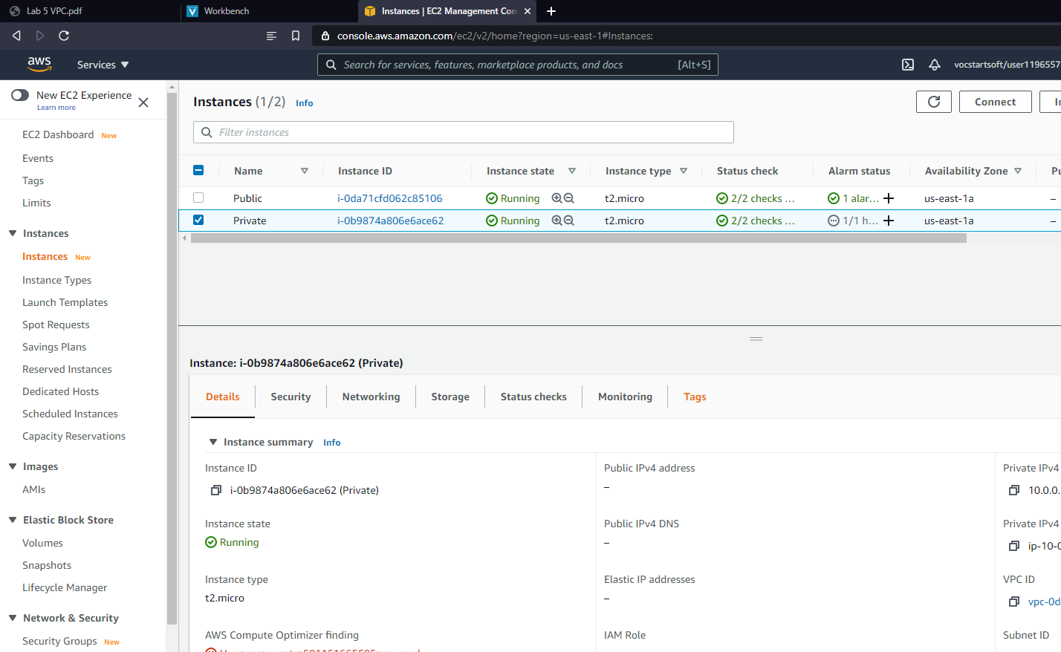

Select the S3 Service. Verify VPC Endpoint Access to S3, Check the route table to make sure you see a route using the VPC endpoint to S3.



To verify, SSH into the public instance, SSH into the private instance, Check the accessibility of the AWS resources privately and confirm that the S3 buckets is in our environment.

